**Capstone Project**

**Case Study-1 Email Marketing Campaign**

**Objective**:

Analyze Email Marketing Campaigns of a Magazine Publisher.

**Data Availability**:

Data available in the form of a csv file (/home/data/CampaignData_full.csv).

Data for 2010 and 2011.

**Reports Requirements**

Find the Click to Open Rate (CTOR)

1. Overall CTOR (use CLICK_FLG and OPEN_FLG column)
2. CTOR by Gender (use I1_GNDR_CODE column)
3. CTOR by Time of the day (use mailed date column)
4. CTOR by Day of the week (use mailed date column)
5. CTOR by Month (use mailed date column)
6. CTOR by Lead’s Income Group (use TRW_INCOME_CD_V4 column)
7. CTOR by Lead’s Ethnicity (use ASIAN_CD column)
8. CTOR by Lead’s Household Status (use I1_INDIV_HHLD_STATUS_CODE column)

This information should be represented in **Tableau/Power BI charts (bar/pie/anything relevant**) which should then be shown on a dashboard.

**Household Members Information**

1. Find count of leads with information about members of their household. If a lead has information about 3 members, and another has information about 2

members and another has none, then the answer to this question is 2.

(use statcd_hh_mem1 - statcd_hh_mem8column)

1. Find count of total number of household members information is available. For example, if a lead has 3 household members, and another has about 2 members, and the other has none, then the total count of household members is 3+2+0 = 5.
2. Find count of household members by type (Head of Household, Spouse etc.).

%age of household members type. For example, if there are 5 Head of Household, 10 Spouse and 85 in the other categories, then the %age of Spouses is 10.

Step-1:

**Moving Data CampaignData_full.csv to HDFS Location**

hadoop fs -mkdir datasets/FinalCaseStudyGraded

hadoop fs -copyFromLocal CampaignData_full.csv datasets/FinalCaseStudyGraded/

hadoop fs -ls datasets/FinalCaseStudyGraded/

Step-2:

**Loading Data to PIG:**

pig -x mapreduce

register '/home/Jig14737/datasets/piggybank.jar';

define CSVLoader org.apache.pig.piggybank.storage.CSVLoader();

CampaignData = LOAD 'datasets/FinalCaseStudyGraded/CampaignData_full.csv' USING CSVLoader AS (CLICK_FLG:chararray, OPEN_FLG:chararray, ADDR_VER_CD:chararray, AQI:chararray, ASIAN_CD:chararray, AUTO_IN_MARKET:chararray, BIRD_QTY:chararray, BUYER_DM_BOOKS:chararray, BUYER_DM_COLLECT_SPC_FOOD:chararray, BUYER_DM_CRAFTS_HOBBI:chararray, BUYER_DM_FEMALE_ORIEN:chararray, BUYER_DM_GARDEN_FARM:chararray, BUYER_DM_GENERAL:chararray, BUYER_DM_GIFT_GADGET:chararray, BUYER_DM_MALE_ORIEN:chararray, BUYER_DM_UPSCALE:chararray, BUYER_MAG_CULINARY_INTERS:chararray, BUYER_MAG_FAMILY_GENERAL:chararray, BUYER_MAG_FEMALE_ORIENTED:chararray, BUYER_MAG_GARDEN_FARMING:chararray, BUYER_MAG_HEALTH_FITNESS:chararray, BUYER_MAG_MALE_SPORT_ORIENTED:chararray, BUYER_MAG_RELIGIOUS:chararray, CATS_QTY:chararray, CEN_2000_MATCH_LEVEL:chararray, CLUB_MEMBER_CD:chararray, COUNTRY_OF_ORIGIN:chararray, DECEASED_INDICATOR:chararray, DM_RESPONDER_HH:chararray, DM_RESPONDER_INDIV:chararray, DMR_CONTRIB_CAT_GENERAL:chararray, DMR_CONTRIB_CAT_HEALTH_INST:chararray, DMR_CONTRIB_CAT_POLITICAL:chararray, DMR_CONTRIB_CAT_RELIGIOUS:chararray, DMR_DO_IT_YOURSELFERS:chararray, DMR_MISCELLANEOUS:chararray, DMR_NEWS_FINANCIAL:chararray, DMR_ODD_ENDS:chararray, DMR_PHOTOGRAPHY:chararray, DMR_SWEEPSTAKES:chararray, DOG_QTY:chararray, DWELLING_TYPE:chararray, DWELLING_UNIT_SIZE:chararray, EST_LOAN_VALUE_RATIO:chararray, ETECH_GROUP:chararray, ETHNIC_GROUP_CODE:chararray, ETHNIC_INSIGHT_MTCH_FLG:chararray, ETHNICITY_DETAIL:chararray, EXPERIAN_INCOME_CD:chararray, EXPERIAN_INCOME_CD_V4:chararray, GNDR_OF_CHLDRN_0_3:chararray, GNDR_OF_CHLDRN_10_12:chararray, GNDR_OF_CHLDRN_13_18:chararray, GNDR_OF_CHLDRN_4_6:chararray, GNDR_OF_CHLDRN_7_9:chararray, HH_INCOME:chararray, HHLD_DM_PURC_CD:chararray, HOME_BUSINESS_IND:chararray, I1_BUSINESS_OWNER_FLG:chararray, I1_EXACT_AGE:chararray, I1_GNDR_CODE:chararray, I1_INDIV_HHLD_STATUS_CODE:chararray, INDIV_EDUCATION:chararray, INDIV_EDUCATION_CONF_LVL:chararray, INDIV_MARITAL_STATUS:chararray, INDIV_MARITAL_STATUS_CONF_LVL:chararray, INS_MATCH_TYPE:chararray, LANGUAGE:chararray, LENGTH_OF_RESIDENCE:chararray, MEDIAN_HOUSING_VALUE:chararray, MEDIAN_LEN_OF_RESIDENCE:chararray, MM_INCOME_CD:chararray, MOSAIC_HH:chararray, MULTI_BUYER_INDIV:chararray, NEW_CAR_MODEL:chararray, NUM_OF_ADULTS_IN_HHLD:chararray, NUMBER_OF_CHLDRN_18_OR_LESS:chararray, OCCUP_DETAIL:chararray, OCCUP_MIX_PCT:chararray, PCT_CHLDRN:chararray, PCT_DEROG_TRADES:chararray, PCT_HOUSEHOLDS_BLACK:chararray, PCT_OWNER_OCCUPIED:chararray, PCT_RENTER_OCCUPIED:chararray, PCT_TRADES_NOT_DEROG:chararray, PCT_WHITE:chararray, PHONE_TYPE_CD:chararray, PRES_OF_CHLDRN_0_3:chararray, PRES_OF_CHLDRN_10_12:chararray, PRES_OF_CHLDRN_13_18:chararray, PRES_OF_CHLDRN_4_6:chararray, PRES_OF_CHLDRN_7_9:chararray, PRESENCE_OF_CHLDRN:chararray, PRIM_FEM_EDUC_CD:chararray, PRIM_FEM_OCC_CD:chararray, PRIM_MALE_EDUC_CD:chararray, PRIM_MALE_OCC_CD:chararray, RECIPIENT_RELIABILITY_CD:chararray, RELIGION:chararray, SCS_MATCH_TYPE:chararray, TRW_INCOME_CD:chararray, TRW_INCOME_CD_V4:chararray, USED_CAR_CD:chararray, Y_OWNS_HOME:chararray, Y_PROBABLE_HOMEOWNER:chararray, Y_PROBABLE_RENTER:chararray, Y_RENTER:chararray, YRS_SCHOOLING_CD:chararray, Z_CREDIT_CARD:chararray, age_hh_mem1:chararray, age_hh_mem2:chararray, age_hh_mem3:chararray, age_hh_mem4:chararray, age_hh_mem5:chararray, age_hh_mem6:chararray, age_hh_mem7:chararray, age_hh_mem8:chararray, gender_hh_mem1:chararray, gender_hh_mem2:chararray, gender_hh_mem3:chararray, gender_hh_mem4:chararray, gender_hh_mem5:chararray, gender_hh_mem6:chararray, gender_hh_mem7:chararray, gender_hh_mem8:chararray, statcd_hh_mem1:chararray, statcd_hh_mem2:chararray, statcd_hh_mem3:chararray, statcd_hh_mem4:chararray, statcd_hh_mem5:chararray, statcd_hh_mem6:chararray, statcd_hh_mem7:chararray, statcd_hh_mem8:chararray, trait_cd1:chararray, trait_cd2:chararray, trait_cd3:chararray, trait_cd4:chararray, trait_cd5:chararray, trait_cd6:chararray, trait_cd7:chararray, trait_cd8:chararray, trait_cd9:chararray, trait_cd10:chararray, trait_cd11:chararray, trait_cd12:chararray, trait_cd13:chararray, trait_cd14:chararray, trait_cd15:chararray, trait_cd16:chararray, trait_cd17:chararray, trait_cd18:chararray, trait_cd19:chararray, trait_cd20:chararray, trait_cd21:chararray, trait_cd22:chararray, trait_cd23:chararray, trait_cd24:chararray, trait_cd25:chararray, trait_cd26:chararray, trait_cd27:chararray, trait_cd28:chararray, trait_cd29:chararray, trait_cd30:chararray, trait_cd31:chararray, trait_cd32:chararray, trait_cd33:chararray, trait_cd34:chararray, trait_cd35:chararray, trait_cd36:chararray, trait_cd37:chararray, trait_cd38:chararray, trait_cd39:chararray, trait_cd40:chararray, trait_cd41:chararray, trait_cd42:chararray, trait_cd43:chararray, trait_cd44:chararray, trait_cd45:chararray, trait_cd46:chararray, trait_cd47:chararray, trait_cd48:chararray, trait_cd49:chararray, trait_cd50:chararray, trait_cd51:chararray, trait_cd52:chararray, trait_cd53:chararray, trait_cd54:chararray, trait_cd55:chararray, trait_cd56:chararray, trait_cd57:chararray, trait_cd58:chararray, trait_cd59:chararray, trait_cd60:chararray, trait_cd61:chararray, trait_cd62:chararray, trait_cd63:chararray, trait_cd64:chararray, trait_typ_cd1:chararray, trait_typ_cd2:chararray, trait_typ_cd3:chararray, trait_typ_cd4:chararray, trait_typ_cd5:chararray, trait_typ_cd6:chararray, trait_typ_cd7:chararray, trait_typ_cd8:chararray, trait_typ_cd9:chararray, trait_typ_cd10:chararray, trait_typ_cd11:chararray, trait_typ_cd12:chararray, trait_typ_cd13:chararray, trait_typ_cd14:chararray, trait_typ_cd15:chararray, trait_typ_cd16:chararray, trait_typ_cd17:chararray, trait_typ_cd18:chararray, trait_typ_cd19:chararray, trait_typ_cd20:chararray, trait_typ_cd21:chararray, trait_typ_cd22:chararray, trait_typ_cd23:chararray, trait_typ_cd24:chararray, trait_typ_cd25:chararray, trait_typ_cd26:chararray, trait_typ_cd27:chararray, trait_typ_cd28:chararray, trait_typ_cd29:chararray, trait_typ_cd30:chararray, trait_typ_cd31:chararray, trait_typ_cd32:chararray, trait_typ_cd33:chararray, trait_typ_cd34:chararray, trait_typ_cd35:chararray, trait_typ_cd36:chararray, trait_typ_cd37:chararray, trait_typ_cd38:chararray, trait_typ_cd39:chararray, trait_typ_cd40:chararray, trait_typ_cd41:chararray, trait_typ_cd42:chararray, trait_typ_cd43:chararray, trait_typ_cd44:chararray, trait_typ_cd45:chararray, trait_typ_cd46:chararray, trait_typ_cd47:chararray, trait_typ_cd48:chararray, trait_typ_cd49:chararray, trait_typ_cd50:chararray, trait_typ_cd51:chararray, trait_typ_cd52:chararray, trait_typ_cd53:chararray, trait_typ_cd54:chararray, trait_typ_cd55:chararray, trait_typ_cd56:chararray, trait_typ_cd57:chararray, trait_typ_cd58:chararray, trait_typ_cd59:chararray, trait_typ_cd60:chararray, trait_typ_cd61:chararray, trait_typ_cd62:chararray, trait_typ_cd63:chararray, trait_typ_cd64:chararray, CITY:chararray, POSTAL_CD:chararray, STATE_PROVINCE:chararray, new_id:chararray, list_auth_cd:chararray, list_auth_flg:chararray, new_list_id:chararray, list_new_brand_cd:chararray, list_new_ed_cd:chararray, new_mailing_id:chararray, Mailing_Category:chararray, Mailed_Date:chararray);

Step-3:

CampaignData1 = FOREACH CampaignData generate CLICK_FLG,OPEN_FLG,I1_GNDR_CODE,

SUBSTRING(Mailed_Date,5,13) As

Date,CONCAT('20',SUBSTRING(Mailed_Date,11,13)) As

Year,(SUBSTRING(Mailed_Date,5,7)=='01' ? 'January' : (

SUBSTRING(Mailed_Date,5,7)=='02' ? 'February' : (SUBSTRING(Mailed_Date,5,7)=='03' ?

'March' :(SUBSTRING(Mailed_Date,5,7)=='04' ? 'April'

:(SUBSTRING(Mailed_Date,5,7)=='05' ? 'May' :(SUBSTRING(Mailed_Date,5,7)=='06' ?

'June' :(SUBSTRING(Mailed_Date,5,7)=='07' ? 'July' :(SUBSTRING(Mailed_Date,5,7)=='08'

? 'August' :(SUBSTRING(Mailed_Date,5,7)=='09' ? 'September'

:(SUBSTRING(Mailed_Date,5,7)=='10' ? 'October' :(SUBSTRING(Mailed_Date,5,7)=='11' ?

'November' :'December'))))))))))) As Month,SUBSTRING(Mailed_Date,0,3) as

Day,SUBSTRING(Mailed_Date,14,19) as TimeStamp,SUBSTRING(Mailed_Date,20,22) as AMPM,

TRW_INCOME_CD,ASIAN_CD,I1_INDIV_HHLD_STATUS_CODE,

statcd_hh_mem1,statcd_hh_mem2,statcd_hh_mem3,statcd_hh_mem4,statcd_hh_mem5,statcd_hh_mem6,statcd_hh_mem7,statcd_hh_mem8,

PRESENCE_OF_CHLDRN,NUMBER_OF_CHLDRN_18_OR_LESS,GNDR_OF_CHLDRN_0_3,GNDR_OF_CHLDRN_10_12,GNDR_OF_CHLDRN_13_18;

CampaignData1 = FOREACH CampaignData generate CLICK_FLG As click,

OPEN_FLG as open,

I1_GNDR_CODE as gender,

SUBSTRING(Mailed_Date,5,13) As Date,

CONCAT('20',SUBSTRING(Mailed_Date,11,13)) As Year,

(SUBSTRING(Mailed_Date,5,7)=='01' ? 'January' : (SUBSTRING(Mailed_Date,5,7)=='02' ? 'February' : (SUBSTRING(Mailed_Date,5,7)=='03' ?

'March' :(SUBSTRING(Mailed_Date,5,7)=='04' ? 'April' : (SUBSTRING(Mailed_Date,5,7)=='05' ? 'May' :(SUBSTRING(Mailed_Date,5,7)=='06' ?

'June' :(SUBSTRING(Mailed_Date,5,7)=='07' ? 'July' :(SUBSTRING(Mailed_Date,5,7)=='08' ? 'August' :(SUBSTRING(Mailed_Date,5,7)=='09' ? 'September'

:(SUBSTRING(Mailed_Date,5,7)=='10' ? 'October' :(SUBSTRING(Mailed_Date,5,7)=='11' ? 'November' :'December'))))))))))) As Month,SUBSTRING(Mailed_Date,0,3) as Day,

SUBSTRING(Mailed_Date,14,19) as TimeStamp,SUBSTRING(Mailed_Date,20,22) as AMPM,

TRW_INCOME_CD as leadIncomee,

ASIAN_CD as leadEthnic,

I1_INDIV_HHLD_STATUS_CODE as leadHouseholdStatus,

statcd_hh_mem1 as hhm1,

statcd_hh_mem2 as hhm2,

statcd_hh_mem3 as hhm3,

statcd_hh_mem4 as hhm4,

statcd_hh_mem5 as hhm5,

statcd_hh_mem6 as hhm6,

statcd_hh_mem7 as hhm7,

statcd_hh_mem8 as hhm8,

PRESENCE_OF_CHLDRN as presChild,

NUMBER_OF_CHLDRN_18_OR_LESS as child18,

GNDR_OF_CHLDRN_0_3 as gender3,

GNDR_OF_CHLDRN_10_12 as gender12,

GNDR_OF_CHLDRN_13_18 as gender18;

STORE CampaignData1 INTO 'datasets/FinalCaseStudyGraded/pigop' USING PigStorage('|');

hadoop fs -ls 'datasets/FinalCaseStudyGraded/pigop/'

**HIVE Solution**

**================**

hive

use hivedb;

set hive.cli.print.current.db;

set hive.cli.print.current.db=true;

Step-5

Create table in Hive and store data from HDFS:

CREATE EXTERNAL TABLE final_graded_assign (click string, open string, gender string, datepart string, Year string, Month string, Day string,TimeStampPart string, AMPM string,

leadIncome string, leadEthnic string, leadHouseholdStatus string, hhm1 string, hhm2 string, hhm3 string, hhm4 string, hhm5 string, hhm6 string, hhm7 string, hhm8 string,

presChild string, child18 string, gender3 string, gender12 string, gender18 string)

ROW FORMAT DELIMITED

FIELDS TERMINATED BY '|';

LOAD DATA INPATH 'datasets/FinalCaseStudyGraded/pigop/' OVERWRITE INTO table final_graded_assign;

Step-6

Select count(*) from final_graded_assign;

Select * from final_graded_assign;

--1785422

Step-7

Find the click to open ratio

Create table Camp_ClickToOpenRatio AS

SELECT ROUND(SUM(CASE WHEN click ='Y' THEN 1 ELSE 0 END)/count(*) * 100,2) CTOR

FROM final_graded_assign

WHERE open='Y';

**Find the Click to Open Rate(CTOR) -- Tableau**

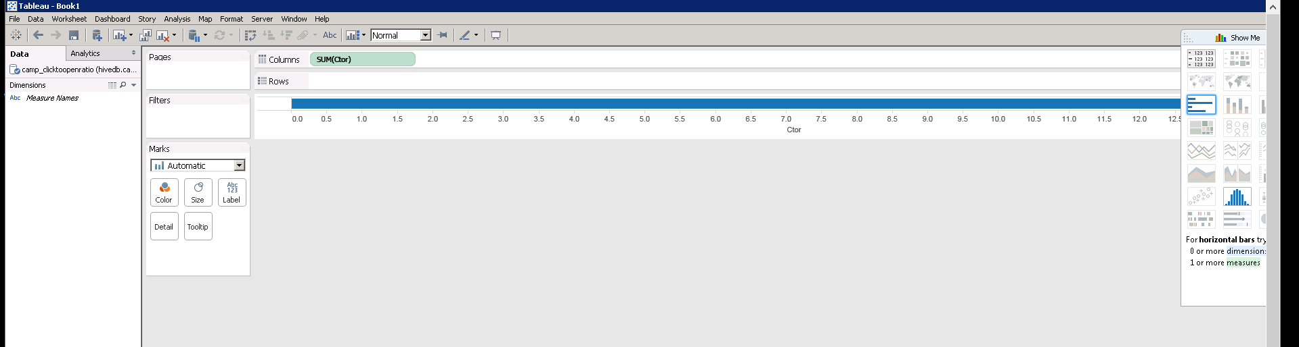

Step-9

CTOR by Gender:

Create table Camp_ctorGender AS SELECT gender, ROUND(SUM(CASE WHEN click = 'Y' THEN 1 ELSE 0 END)/count(*) * 100,2) CTOR

FROM final_graded_assign

WHERE open='Y' GROUP BY gender;

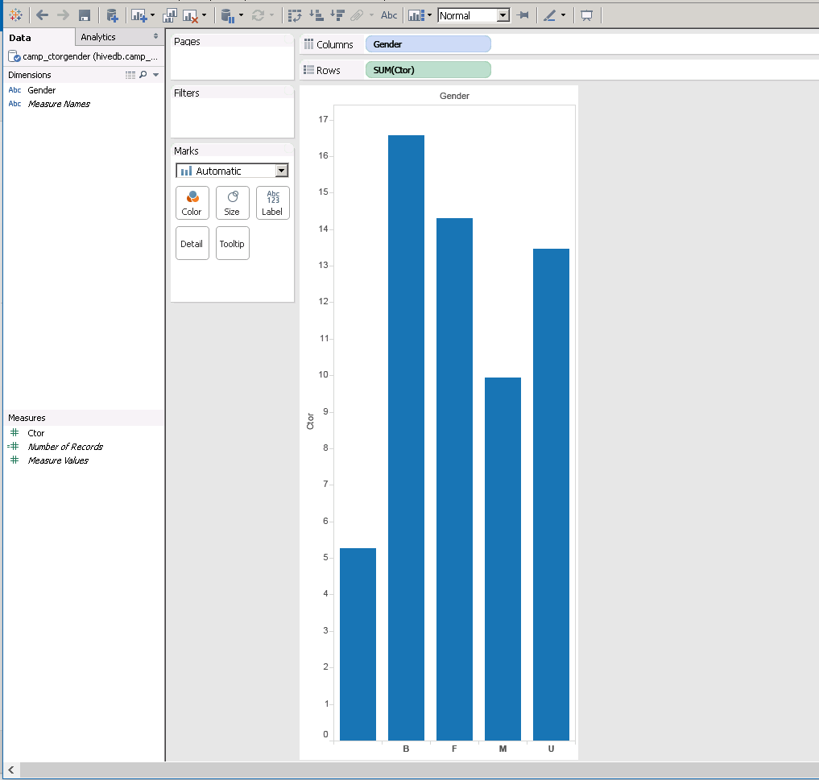

Step-10

Select * from Camp_ctorGender;

Step-DatePart

CTOR by DatePart:

Create table Camp_ctorDatePart AS

SELECT datepart, ROUND(SUM(CASE WHEN click = 'Y' THEN 1 ELSE 0 END)/count(*) * 100,2) CTOR

FROM final_graded_assign

WHERE open='Y'

GROUP BY datepart;

Select * from Camp_ctorDatePart; **-- Tableau**

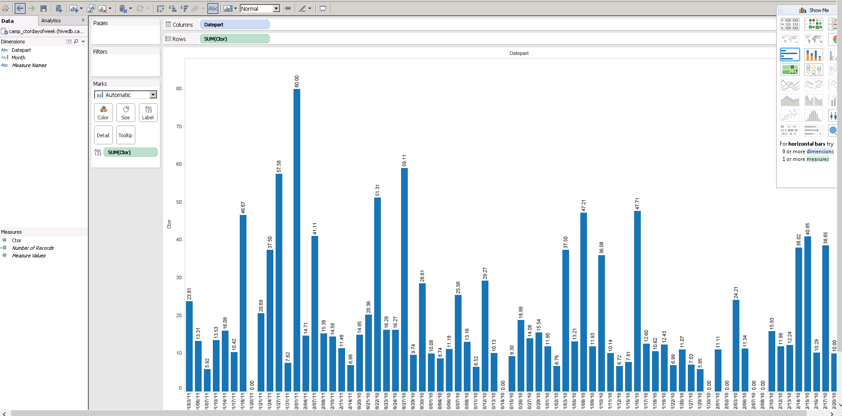

Step-11

CTOR by Day of the Week:

Create table Camp_ctorDayofWeek AS

SELECT Day, ROUND(SUM(CASE WHEN click = 'Y' THEN 1 ELSE 0 END)/count(*) * 100,2) CTOR

FROM final_graded_assign

WHERE open='Y'

GROUP BY Day;

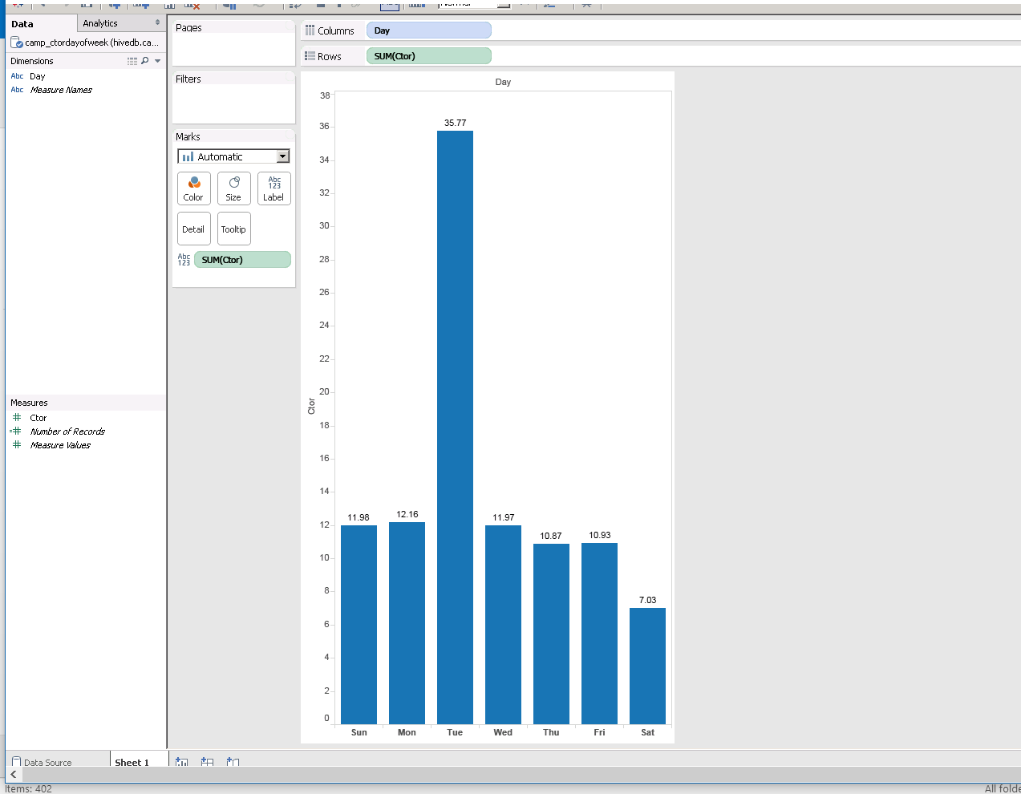

Step-12

Select * from Camp_ctorDayofWeek;

Step-13

CTOR by Month of the Year:

Create table Camp_ctorMonthofYear AS SELECT Month, ROUND(SUM(CASE

WHEN click = 'Y' THEN 1 ELSE 0 END)/count(*) * 100,2) CTOR

FROM final_graded_assign

WHERE open='Y' GROUP BY Month;

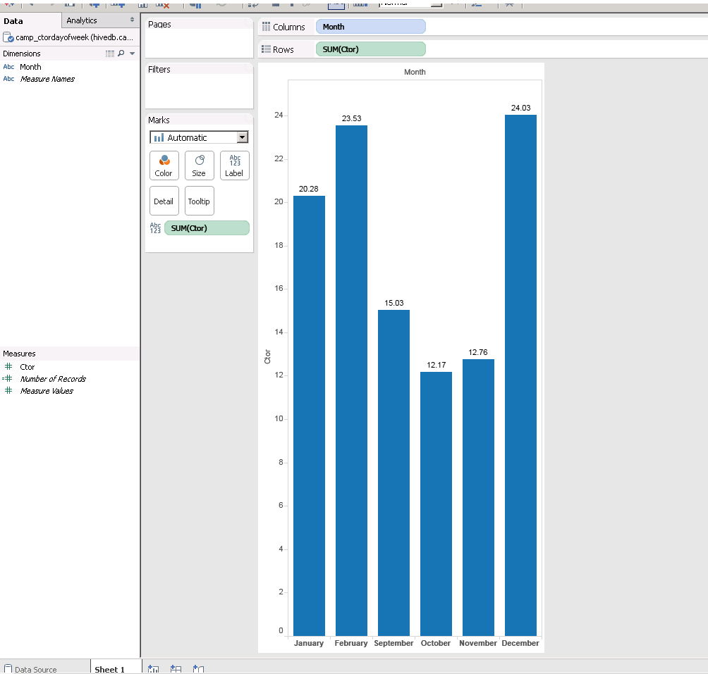

Step-14

Select * from Camp_ctorMonthofYear;

Step-14

Select * from Camp_ctorMonthofYear;

Step-15

CTOR by Lead's Income Group:

Create table Camp_ctorIncome AS SELECT leadIncome, ROUND(SUM(CASE WHEN click = 'Y' THEN 1 ELSE 0 END)/count(*) * 100,2) CTOR

FROM final_graded_assign

WHERE open='Y' GROUP BY leadIncome;

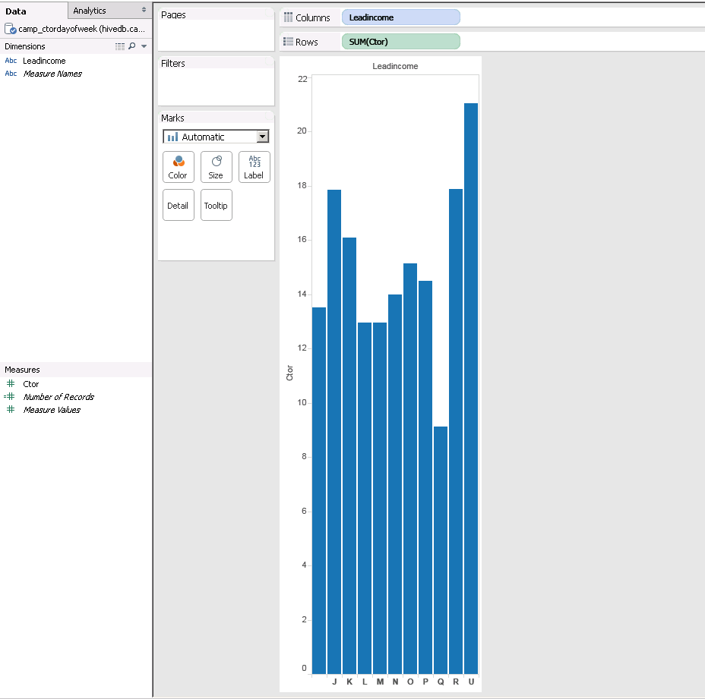

Step-16

CTOR by Lead's Ethnic Group:

Create table Camp_ctorEthnic AS SELECT leadEthnic, ROUND(SUM(CASE WHEN click = 'Y' THEN 1 ELSE 0 END)/count(*) * 100,2) CTOR

FROM final_graded_assign

WHERE open='Y' GROUP BY leadEthnic;

Select * from Camp_ctorEthnic; **-- Tableau**

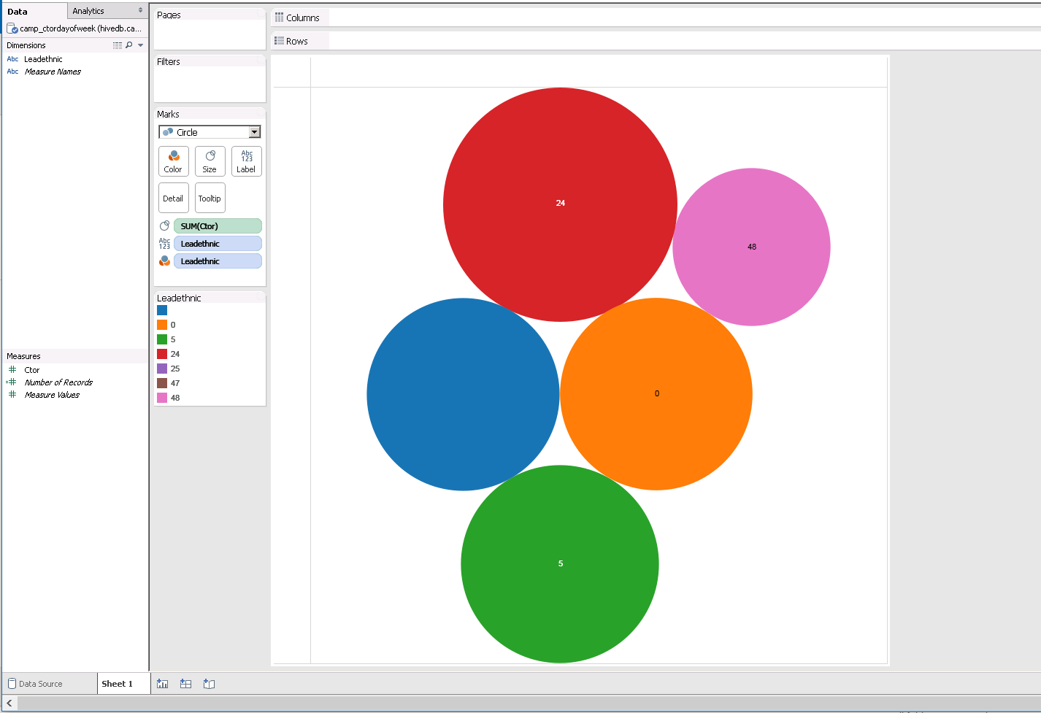

Step-17

CTOR by Lead's Household Status Group:

Create table Camp_ctorHouseholdStatus AS SELECT leadHouseholdStatus, ROUND(SUM(CASE WHEN click = 'Y' THEN 1 ELSE 0 END)/count(*) * 100,2) CTOR

FROM final_graded_assign

WHERE open='Y' GROUP BY leadHouseholdStatus;

Select * from Camp_ctorHouseholdStatus; **-- Tableau**

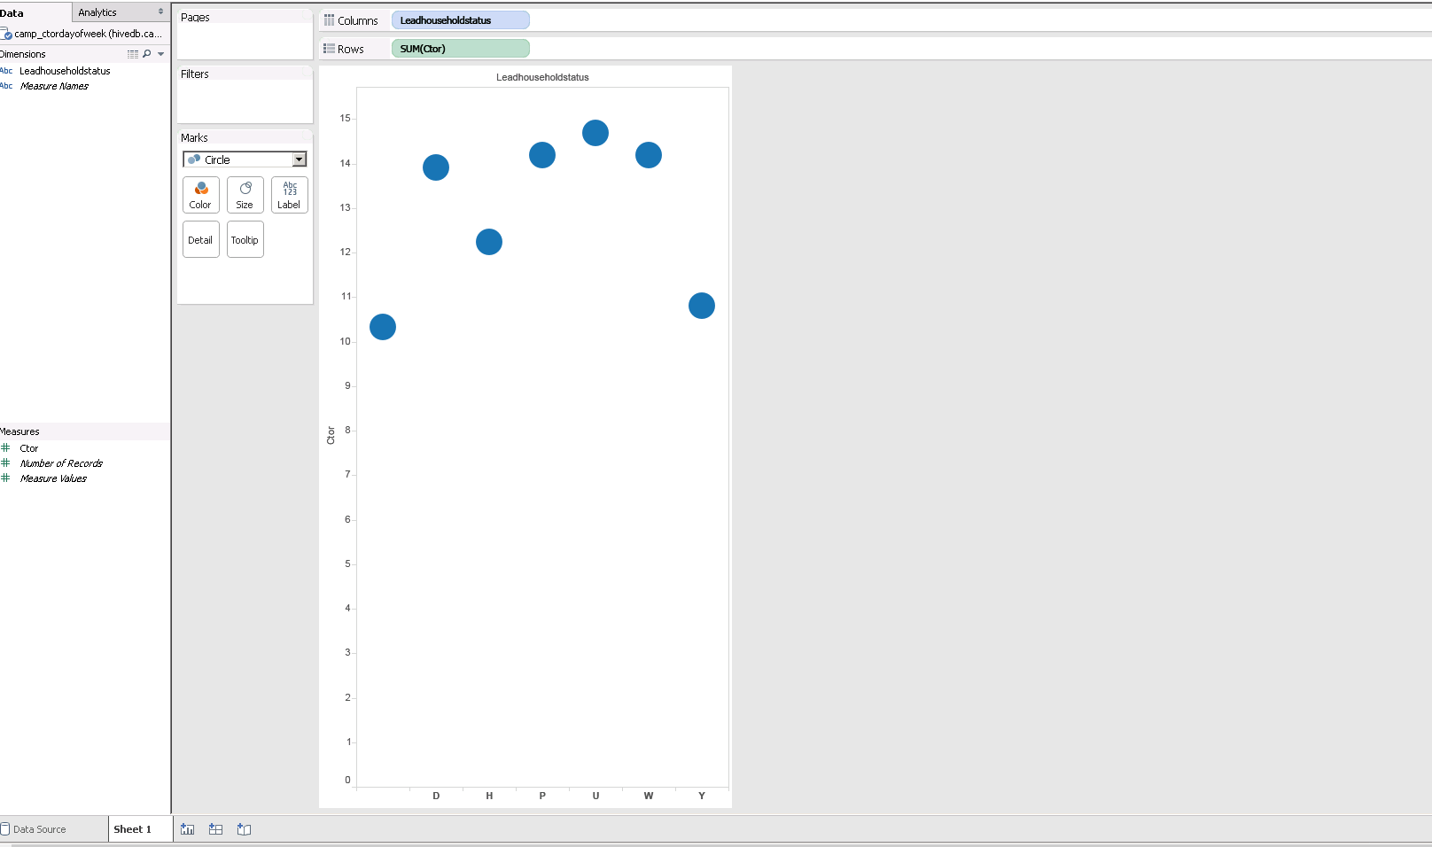

Step - 18

Create table Camp_ctorhouseholdMI as

select leadHouseholdStatus,

sum((case when hhm1 is NULL then 0 else 1 end) + (case when hhm2 is NULL then 0 else 1 end) +

(case when hhm3 is NULL then 0 else 1 end) + (case when hhm4 is NULL then 0 else 1 end) +

(case when hhm5 is NULL then 0 else 1 end) + (case when hhm6 is NULL then 0 else 1 end) +

(case when hhm7 is NULL then 0 else 1 end) + (case when hhm8 is NULL then 0 else 1 end)) ctor

from final_graded_assign

WHERE open='Y' GROUP BY leadHouseholdStatus;

**-- Tableau**

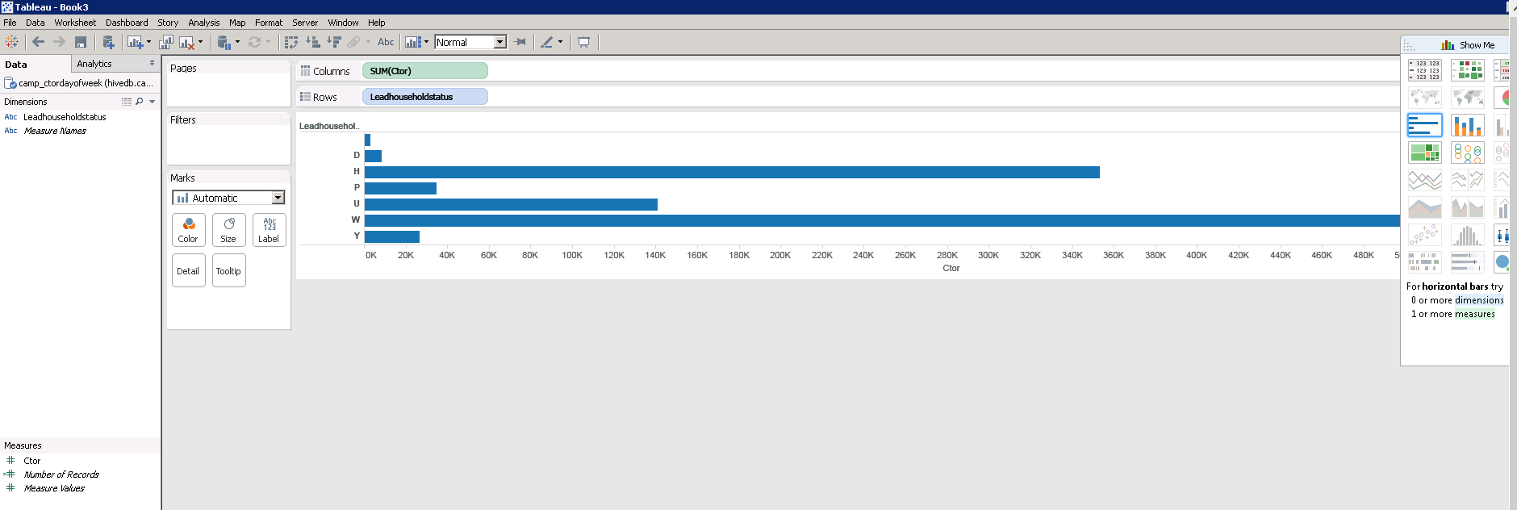

Step – 19

create table Camp_ctorhousehold_children18_or_less as

select leadHouseholdStatus, sum((case when presChild='Y' then 1 else 0 end) | (case when child18=1 then 1 else 0 end) ) CTOR

from final_graded_assign

where leadHouseholdStatus!='U'

GROUP BY leadHouseholdStatus;

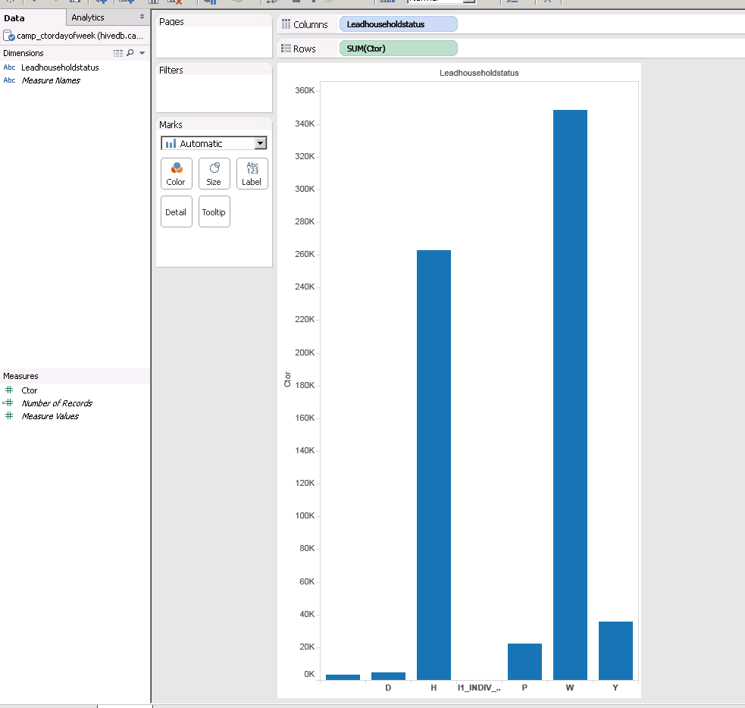

Step – 20

Create table Camp_ctorhousehold_children as

select leadHouseholdStatus, sum((case when presChild='Y' then 1 else 0 end)) CTOR

from final_graded_assign

where leadHouseholdStatus!='U'

GROUP BY leadHouseholdStatus;

Step – 21 **-- Tableau**

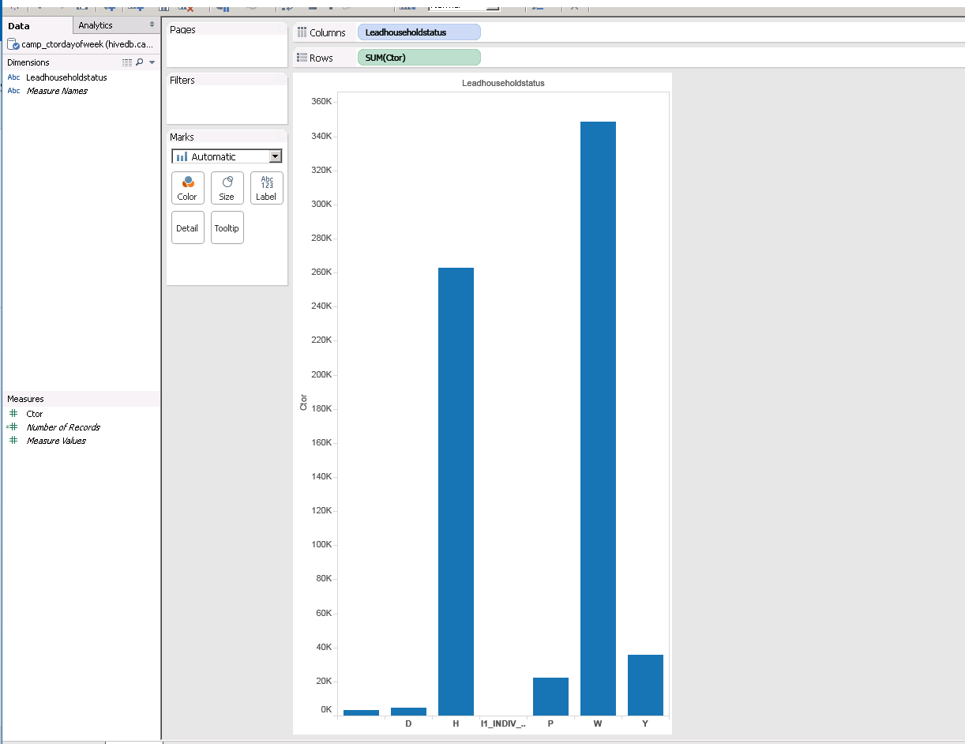

create table Camp_ctorhousehold_male_female as

select leadHouseholdStatus, sum((case when gender3='M' then 1 else 0 end) + (case when gender12='M' then 1 else 0 end) + (case when gender18='M' then 1 else 0 end) ) MALE_CTOR

, sum((case when gender3='F' then 1 else 0 end) + (case when gender12='F' then 1 else 0 end) + (case when gender18='F' then 1 else 0 end) ) FEMALE_CTOR

from final_graded_assign

where leadHouseholdStatus!='U'

GROUP BY leadHouseholdStatus;

